AP Course Information
Advanced Placement Program
What are AP classes?  Advanced Placement courses are college-level courses taken in high school. A national exam is given in May of each year and scored on a 1 to 5 scale. A score of a 3, 4 or 5 is considered passing and leads to college credit in most all 4-year colleges and universities. There are 33 different AP courses available to high school students. | What are AP exams?  AP Exams are administered by schools worldwide on set dates each May. Exams usually last around three hours. Each AP Exam usually consists of multiple-choice questions and free-response questions (essay, problem-solving, oral response).
Why should I consider taking an AP class and an AP exam?
Reason #1: College Credit  Almost all two- and four-year colleges and universities in the United States offer credit and/or advanced placement for qualifying AP Exam scores.  Credit: Students earn credit toward their college degrees.  Advanced placement: Students can skip introductory courses and move directly into higher-level classes, and/or fulfill general education requirements. | Information about AP credit and placement policies at many colleges and universities is available at: https://apstudent.collegeboard.org/creditandplacement/search-credit-policies
Reason #2: Increased College Success  A recent study* showed that students who earned a 3, 4, or 5 on the AP Exam had higher first-year college grade point averages and were more likely to return for the second year of college than non-AP students of similar ability. | Reason #3: Save Money  Students who take five years or more to graduate can spend $8,000 to $27,000 for each additional year in college.  - The typical college cost per year for a four-year public institution is $8,142 for in-state students and $19,670 for out-of-state students.*  - Students attending private institutions might expect to incur $27,389 for each additional year it takes to earn a bachelor’s degree.*
How do I register for an AP exam?  AP Exam fee is $94 per exam. Pick up a registration form at your school, fill it out, and return it to your school bookkeeper.  Do you qualify for free or reduced priced lunch?  If you qualify for free or reduced priced lunch, you can take the AP exam for free due to a fee reduction from the College Board and a grant from the United Way of Central Iowa. You must register BEFORE November 11. This is the final deadline for signing up! | How do I find out my AP exam scores?  AP exams are taken in May and graded in June. Scores are reported online in July.  AP exam scores are uploaded into Infinite Campus so you always have access to your assessment information.  AP Exam scores are NOT a part of your school transcript.  Unlike the ACT and SAT exam scores which are automatically reported to colleges and universities, you decide if and when you choose to report your AP exam score(s) to colleges and universities.

AP Exam Registration Information
AP Exam registration begins Monday, September 30 for Spring 2020 Exams!
Students pick up an exam order form from the bookkeeper in the main office. AP Exam registration forms must be submitted by November 11, 2019.
A few reminders about AP Exam Registration:
- Each AP Exam cost $94.00: a $40 non-refundable deposit is required for each exam.
- Full payment is required before an exam will be ordered. No refunds will be offered once the exam has been ordered by the school on November 15, 2019.
- Students register for ALL exams (including exams being taken at Central) at their home high school.
- Payment in full for each exam is required no later than March 13, 2020.
- Students who receive fee waivers/textbook exemptions have financial support available from the College Board and the United Way. The cost to take the AP exam is $0.00 for qualifying students, however, the unused/canceled exam fee will apply, if the exam is not taken.
Exam Fees, Rebate, and Fee Reduction
Exam fee for on-time exam orders  *November 11, 2019, for full-year and first-semester courses; March 13, 2020, for courses that start in the second semester. | - $94 per exam  - $142 per exam for AP Capstone Exams (AP Seminar and Research)
Unused/canceled exam fee | $40 per exam for:  - Exams canceled in AP Registration and Ordering after November 15 and by March 13 (11:59 p.m. ET).  - Exams that aren’t taken and are indicated as unused in AP Registration and Ordering before your school’s invoice is generated.
DMPS Financial Support for AP Exam Fees | - -Students who qualify for Free and Reduced Lunch can have exam fees covered by a College Board waiver and United Way Funding. However, the unused/canceled exam fee will apply, if the student cancels or does not show up to take the exam.  - -Students taking AP Environmental Science qualify for assistance through a business-school partnership with EcoEngineers (www.ecoengineers.us). Application forms for this funding are available with your APES teacher beginning in early September.  - Additional financial aid requests for students who do not qualify for Free or Reduced Lunch may be available. Please see your school’s AP Site Coordinator for more information before November 1, 2019.
Students will return completed AP exam order forms with payments to the school bookkeeper, in the main office (office hours are 7:30 a.m.-3:45 p.m.).

AP Exam Registration Timeline: At-a-Glance
DMPS AP Exam Registration Opens for Students | Final Date for Students to Register - DMPS AP Exam Registration | Final Date for Schools to Place the College Board AP Exam Order | Last Date - College Board AP Exam Order Changes  *Second semester AP courses order deadline
Monday, September 30 | Monday, November 11 | Friday, November 15 | Friday, March 13

AP Exam Schedule – 2020

(images on next page)
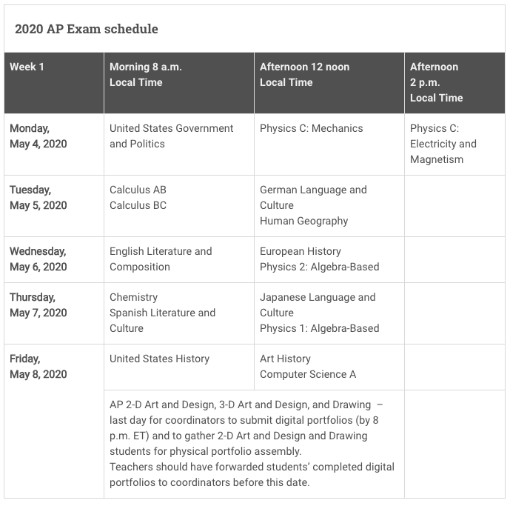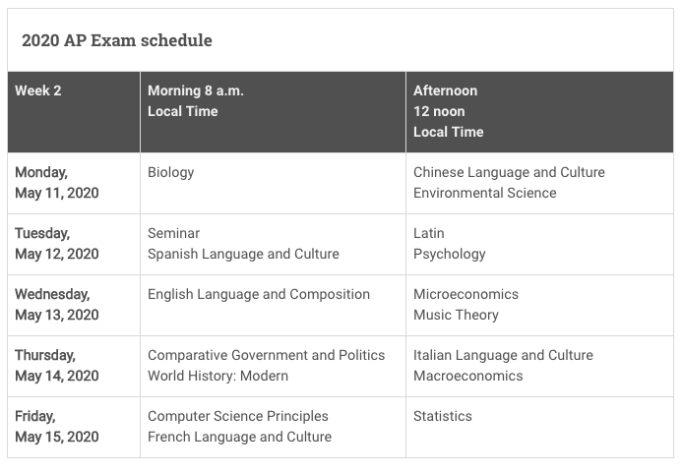
Student Testing Day Exam Policies

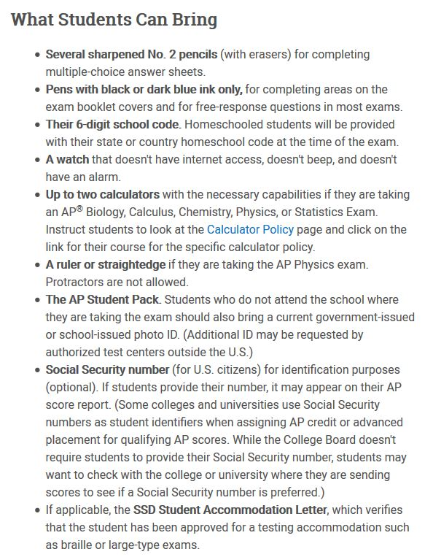 | 